# Screenshots

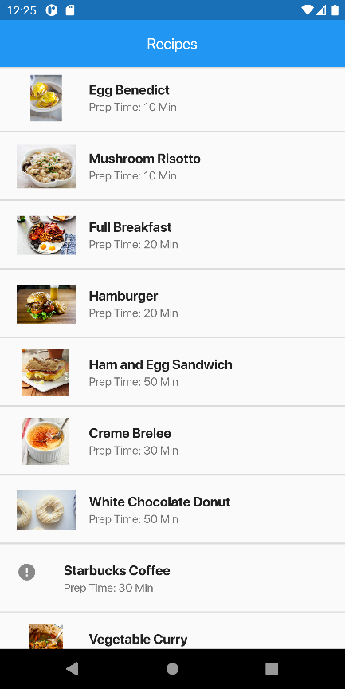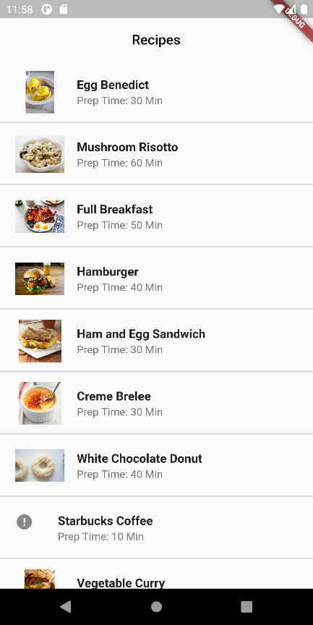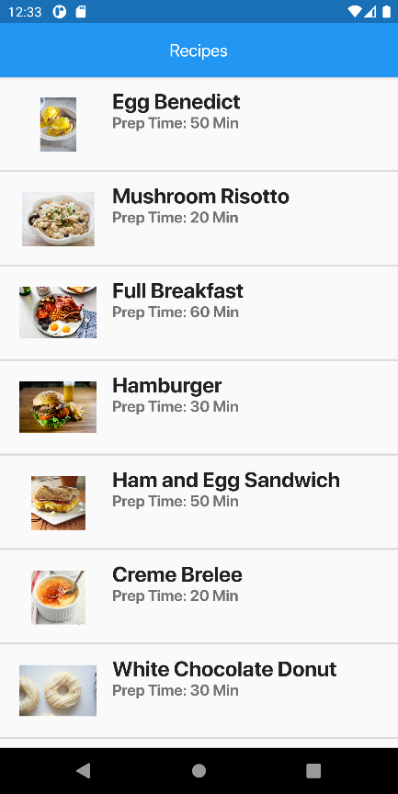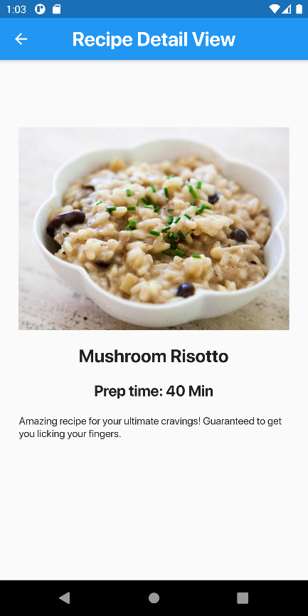

# Solution

## Main.dart

import 'package:flutter/material.dart';  
import 'package:madlab7/recipeDetail.dart';  
import 'package:splashscreen/splashscreen.dart';  
import 'dart:math';  
  
void main() {  
 runApp(MyApp());  
}  
  
class MyApp extends StatelessWidget {  
 @override  
 Widget build(BuildContext context) {  
 return MaterialApp(  
 title: 'MAD LAB 7',  
 debugShowCheckedModeBanner: false,  
 home: Splash(),  
 theme: ThemeData(  
 fontFamily: "SFPro"  
 ),  
 );  
 }  
}  
  
class Splash extends StatelessWidget {  
 @override  
 Widget build(BuildContext context) {  
 return SplashScreen(  
 seconds: 5,  
 backgroundColor: Colors.*white*,  
 image: Image.asset('files/flutter-logo.png'),  
 loaderColor: Colors.*blue*,  
 photoSize: 150,  
 title: Text("Cook Book!", style: TextStyle(fontSize: 18),),  
 navigateAfterSeconds: RecipeView(),  
 );  
 }  
}  
  
class RecipeView extends StatefulWidget {  
 @override  
 _RecipeViewState createState() => _RecipeViewState();  
}  
  
class _RecipeViewState extends State<RecipeView> {  
 Random random = new Random();  
 List<String> recipeImages = [];  
 var prepTime = [  
 "30 Min",  
 "20 Min",  
 "10 Min",  
 "40 Min",  
 "60 Min",  
 "50 Min"  
 ];  
 var recipeNames = [  
 "Egg Benedict",  
 "Mushroom Risotto",  
 "Full Breakfast",  
 "Hamburger",  
 "Ham and Egg Sandwich",  
 "Creme Brulee",  
 "White Chocolate Donut",  
 "Starbucks Coffee",  
 "Vegetable Curry",  
 "Instant Noodle with Egg",  
 "Noodle with BBQ Pork",  
 "Japanese Noodle with Pork",  
 "Green Tea",  
 "Thai Shrimp Cake",  
 "Angry Birds Cake",  
 "Ham and Cheese Panini",  
 ];  
  
 @override  
 void initState() {  
 super.initState();  
 for (int i = 1; i < 17; i++) {  
 String filename;  
 if (i == 8)  
 filename = "image$i.jpeg";  
 else  
 filename = "image$i.jpg";  
 recipeImages.add(filename);  
 }  
 }  
  
 @override  
 Widget build(BuildContext context) {  
 return Scaffold(  
 appBar: AppBar(  
 elevation: 2,  
 flexibleSpace: Container(decoration: BoxDecoration(color: Colors.*blue*),),  
 backgroundColor: Colors.*transparent*,  
 centerTitle: true,  
 title: Text("Recipes", style: TextStyle(fontSize: 26, color: Colors.*white*),),  
 automaticallyImplyLeading: false,  
 ),  
 body: Column(  
 crossAxisAlignment: CrossAxisAlignment.start,  
 children: [  
 Expanded(  
 child: ListView.separated(  
 padding: EdgeInsets.*zero*,  
 itemCount: recipeImages.length,  
 separatorBuilder: (ctx, index) => Divider(height: 0, thickness: 2,),  
 itemBuilder: (ctx, index) {  
 String time = prepTime[random.nextInt(prepTime.length)];  
 return ListTile(  
 dense: false,  
 contentPadding: EdgeInsets.symmetric(horizontal: 20, vertical: 5),  
 leading: Image.asset("files/recipeImages/" + recipeImages[index], errorBuilder: (ctx,obj,trace) => Icon(Icons.*error*,), width: 80,),  
 title: Text(recipeNames[index], style: TextStyle(fontSize: 22, fontWeight: FontWeight.*w800*),),  
 subtitle: Text("Prep Time: $time", style: TextStyle(fontSize: 16, fontWeight: FontWeight.*w800*)),  
 isThreeLine: true,  
 onTap: (){Navigator.*of*(context).push(MaterialPageRoute(builder: (context) => RecipeDetailsScreen(recipeNames[index], time, recipeImages[index])));},  
 );  
 },  
 ),  
 )  
 ],  
 ),  
 );  
 }  
}

## Recipe Detail

import 'package:flutter/material.dart';  
  
class RecipeDetailsScreen extends StatefulWidget {  
 String recipeName;  
 String recipeTime;  
 String recipeImage;  
 RecipeDetailsScreen(this.recipeName, this.recipeTime, this.recipeImage);  
 @override  
 _RecipeDetailsScreenState createState() => _RecipeDetailsScreenState();  
}  
  
class _RecipeDetailsScreenState extends State<RecipeDetailsScreen> {  
 @override  
 Widget build(BuildContext context) {  
 return Scaffold(  
 appBar: AppBar(  
 automaticallyImplyLeading: true,  
 centerTitle: true,  
 title: Text("Recipe Detail View", style: TextStyle(fontSize: 26, fontWeight: FontWeight.*w800*),),  
 backgroundColor: Colors.*blue*,  
 ),  
 body: SingleChildScrollView(  
 child: Padding(  
 padding: EdgeInsets.symmetric(vertical: 10, horizontal: 25),  
 child: Column(  
 children: [  
 SizedBox(height: 80,),  
 Image.asset("files/recipeImages/" + widget.recipeImage, errorBuilder: (ctx,obj,trace) => Icon(Icons.*error*,), ),  
 SizedBox(height: 20,),  
 Text(widget.recipeName, style: TextStyle(fontSize: 24, fontWeight: FontWeight.*w800*),),  
 SizedBox(height: 20,),  
 Text("Prep time: ${widget.recipeTime}",style: TextStyle(fontSize: 20, fontWeight: FontWeight.*w800*)),  
 SizedBox(height: 20,),  
 Text("Amazing recipe for your ultimate cravings! Guaranteed to get you licking your fingers.")  
 ],  
 ),  
 ),  
 )  
 );  
 }  
}